1. Hands-on Practice 1: Internet Basics
   1. Command 1: ipconfig/ifconfig

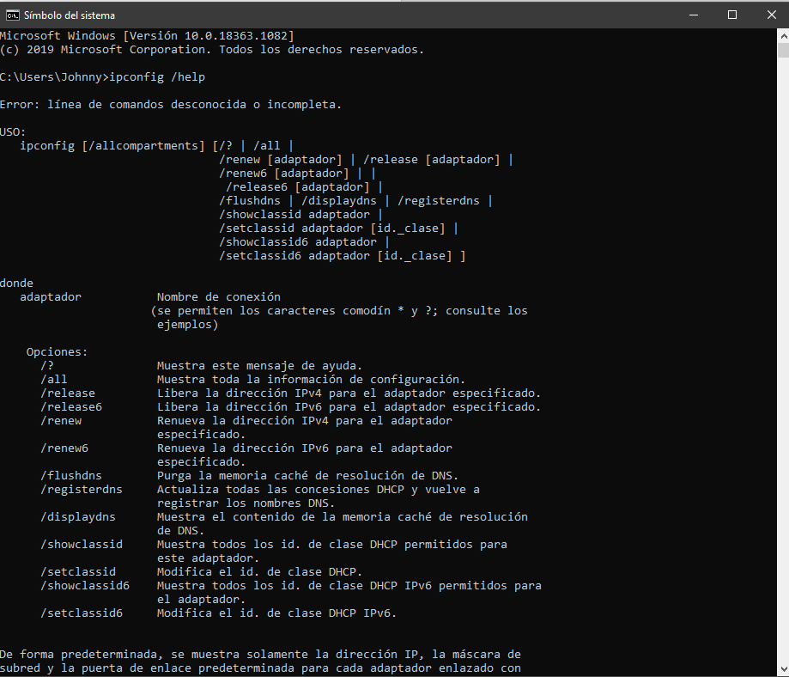

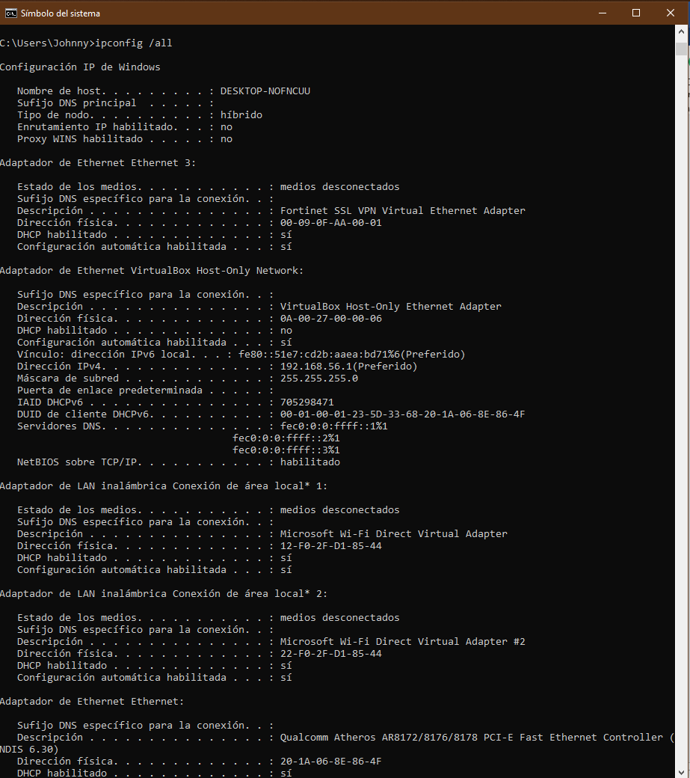

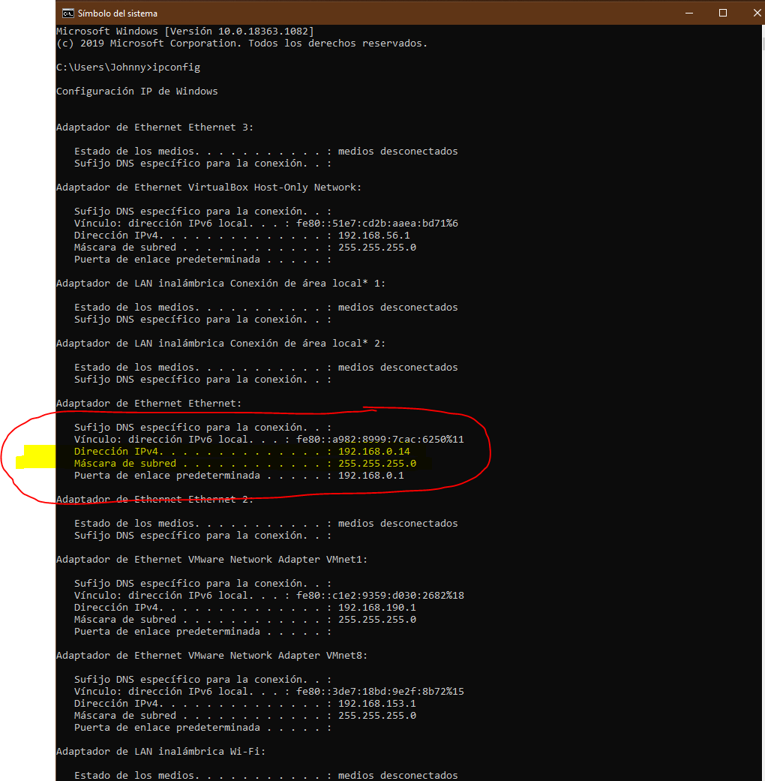

My computer’s IPv4 address is **192.168.0.14**

* 1. Command 1: ipconfig/ifconfig

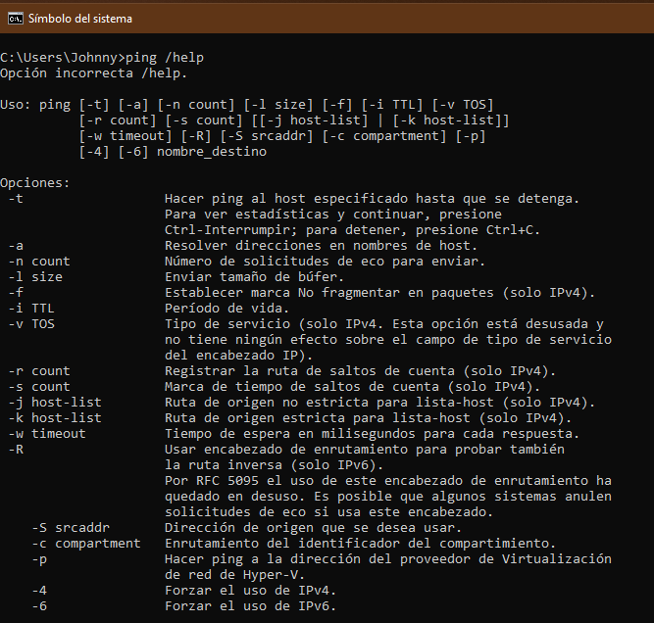

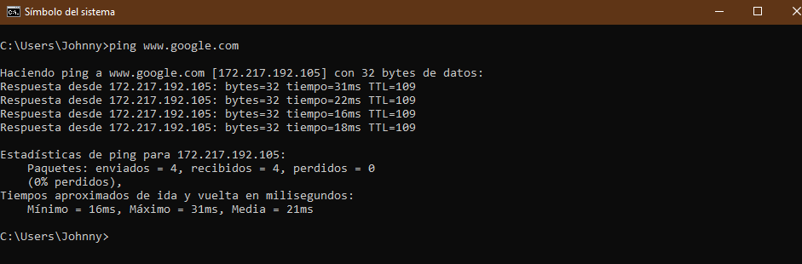

Google’s IP address is **172.217.192.105**

Google did shown 4 response with different time delayed

**Hands-on Practice 2: Heading, Paragraph, Line Break**

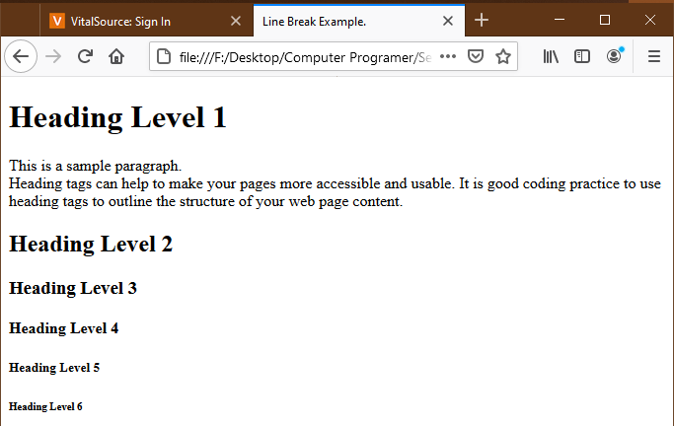

**Hands-on Practice 3: Horizontal Rule Element**

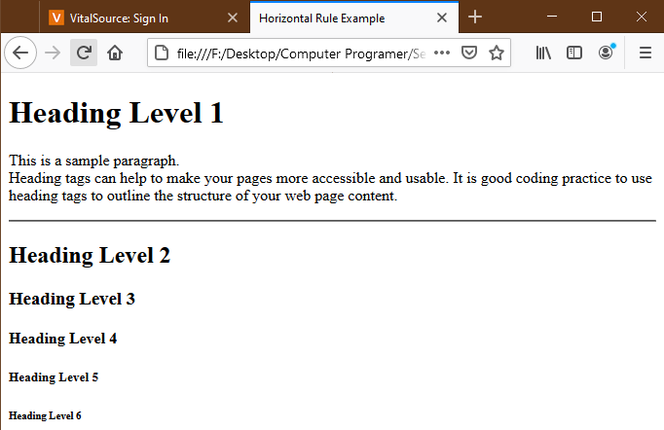

**Hands-on Practice 4: Ordered List and Unordered List**

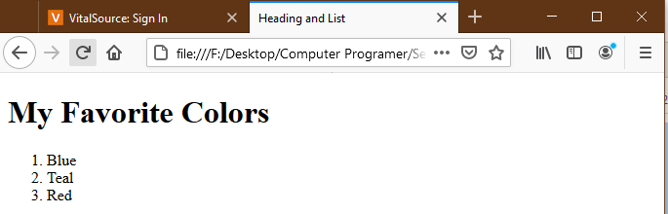

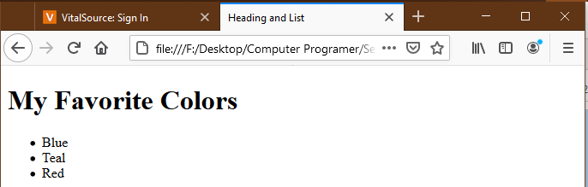

**Hands-on Practice 5: Special Entity Characters – Copyright**

